Honors Calculus Summer Assignment

Directions: All students taking Honors Calculus school year should complete all problems contained in the packet. This material will not be covered in class. You are expected to know all the material enclosed before starting school. During the summer you can email me to ask any questions about the material contained in the packet. I will check my email semi-regularly and will respond when I can. Don’t procrastinate and wait until the last week before school starts to begin completing the packet. My email address is mhausman@bwschools.net.

You should be prepared to take a test on the material covered in this packet when you return to school.

Have a great summer!
Honors Calculus
Summer Review Problems

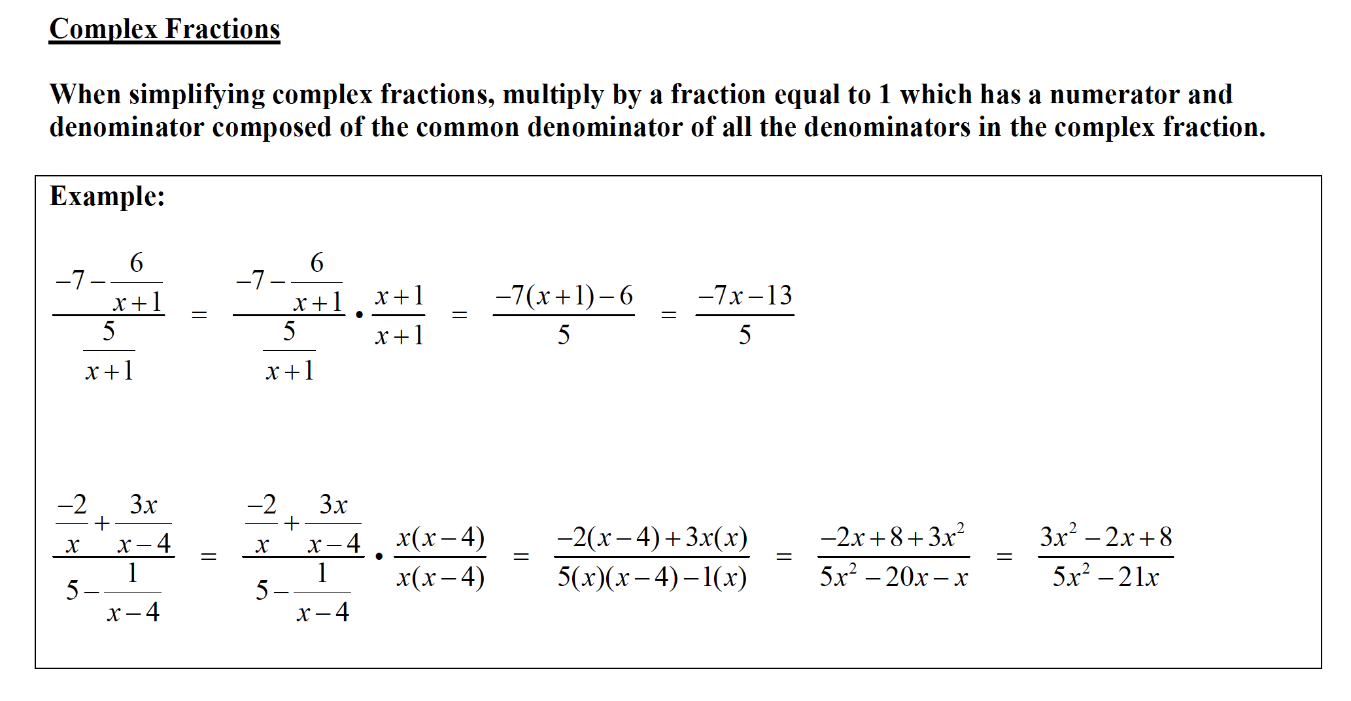
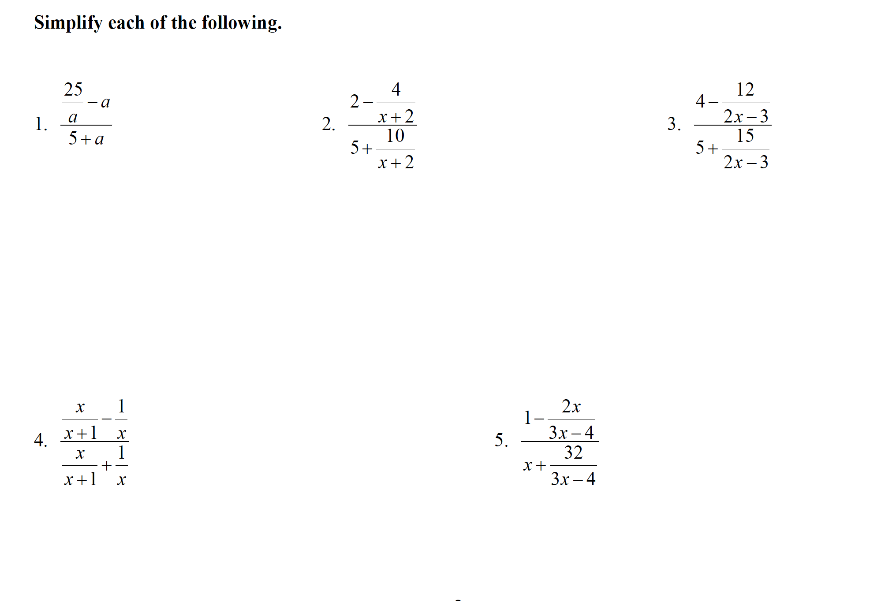

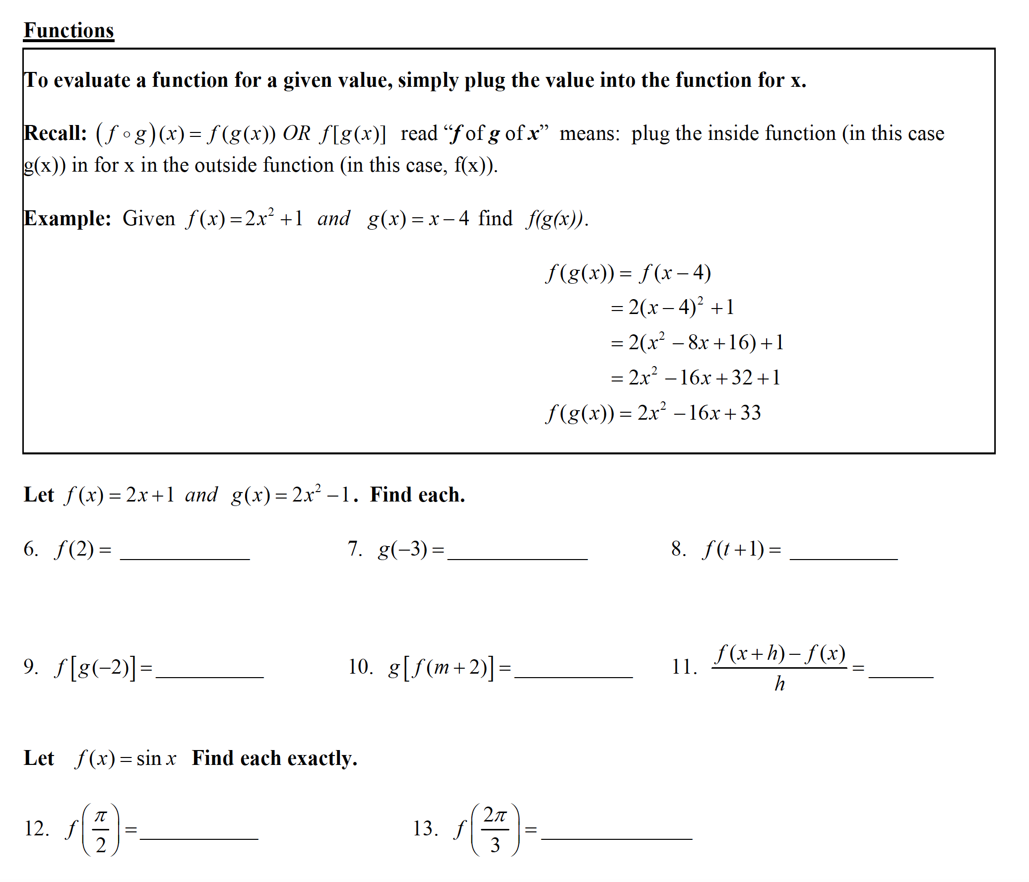

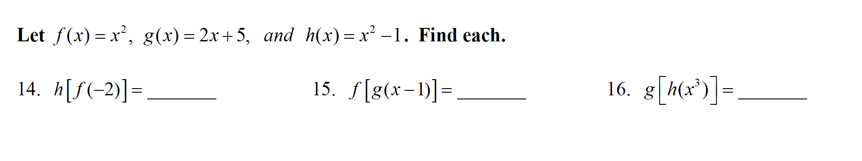
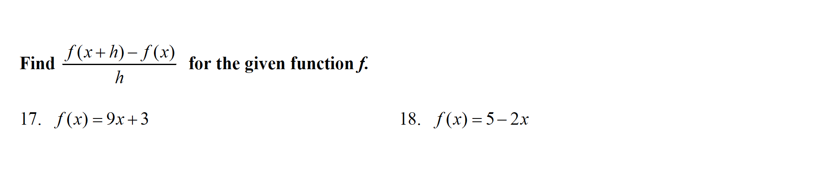

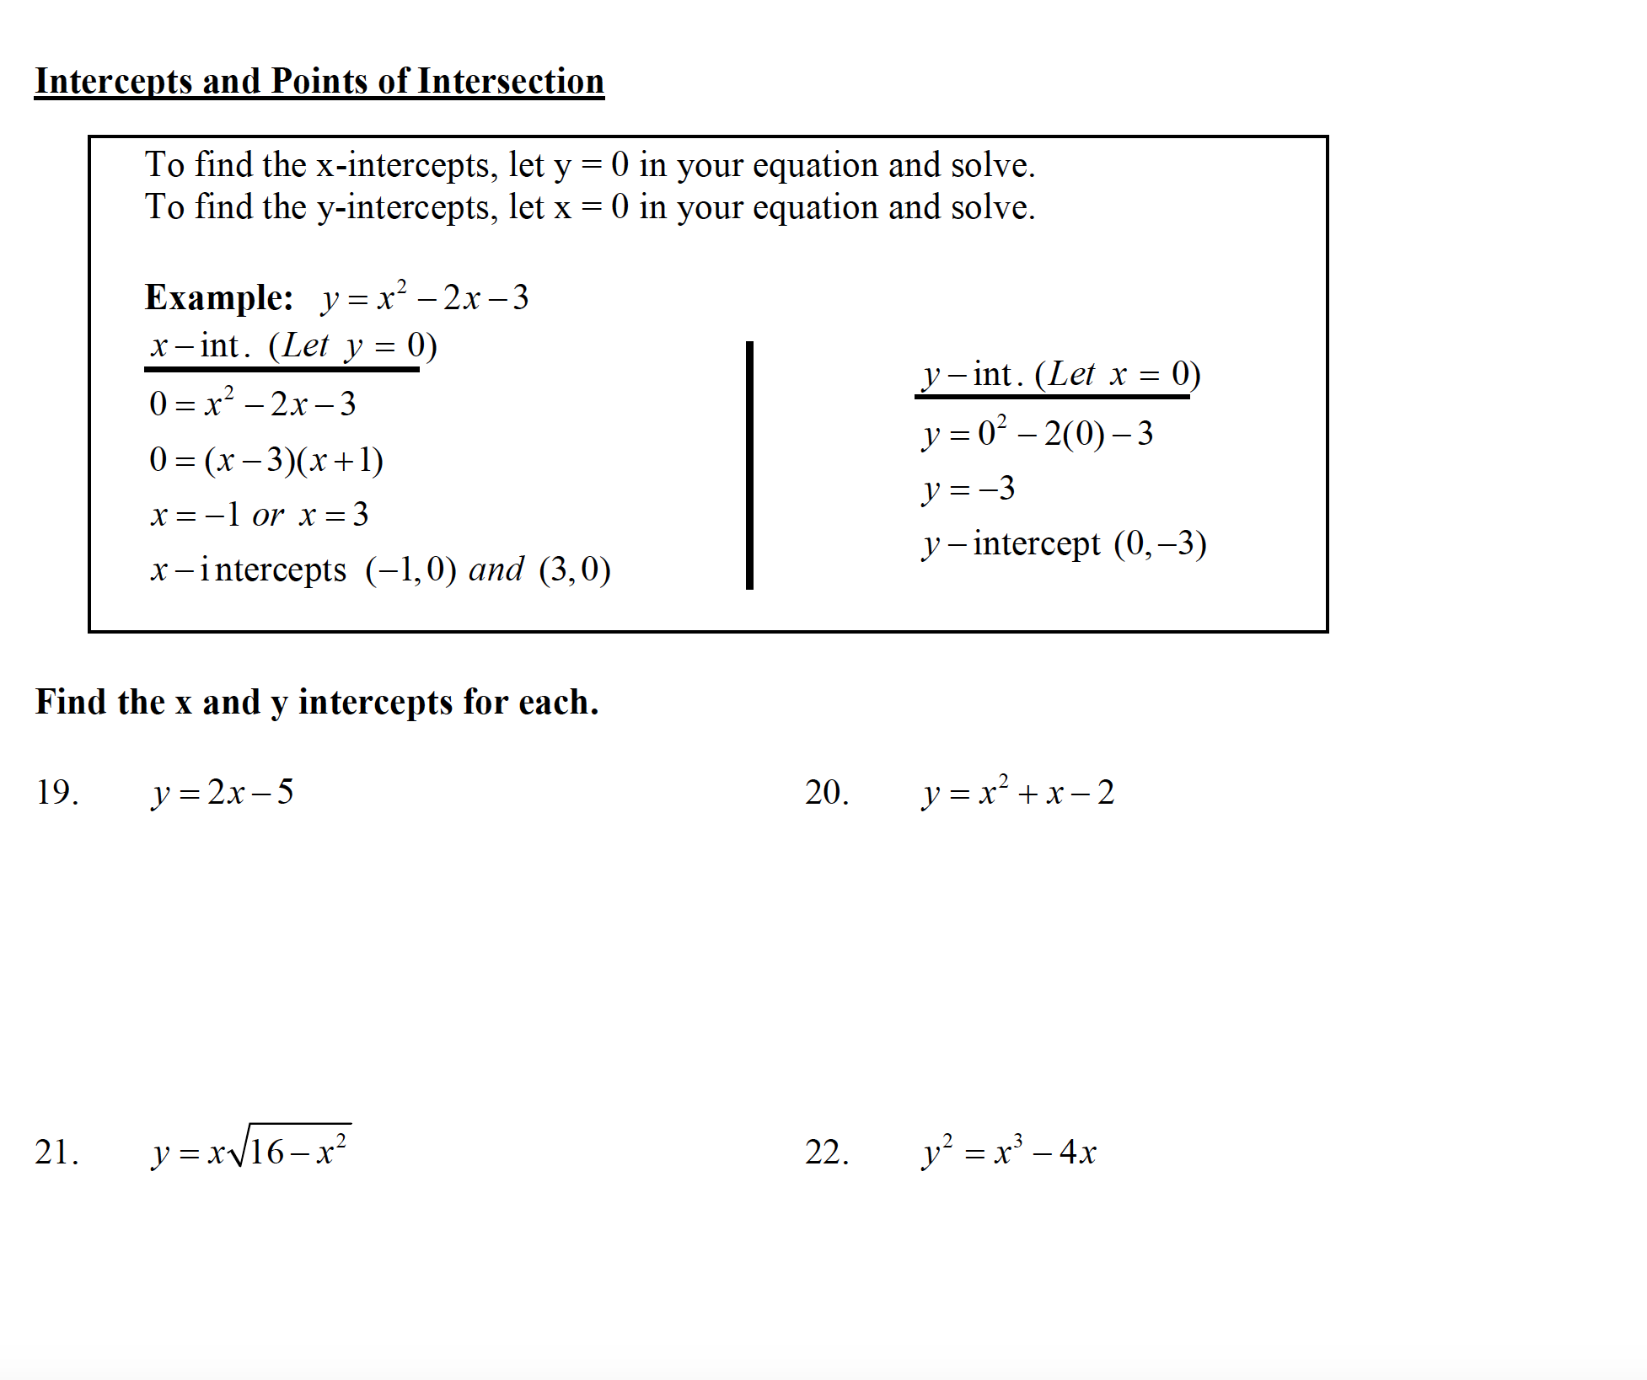
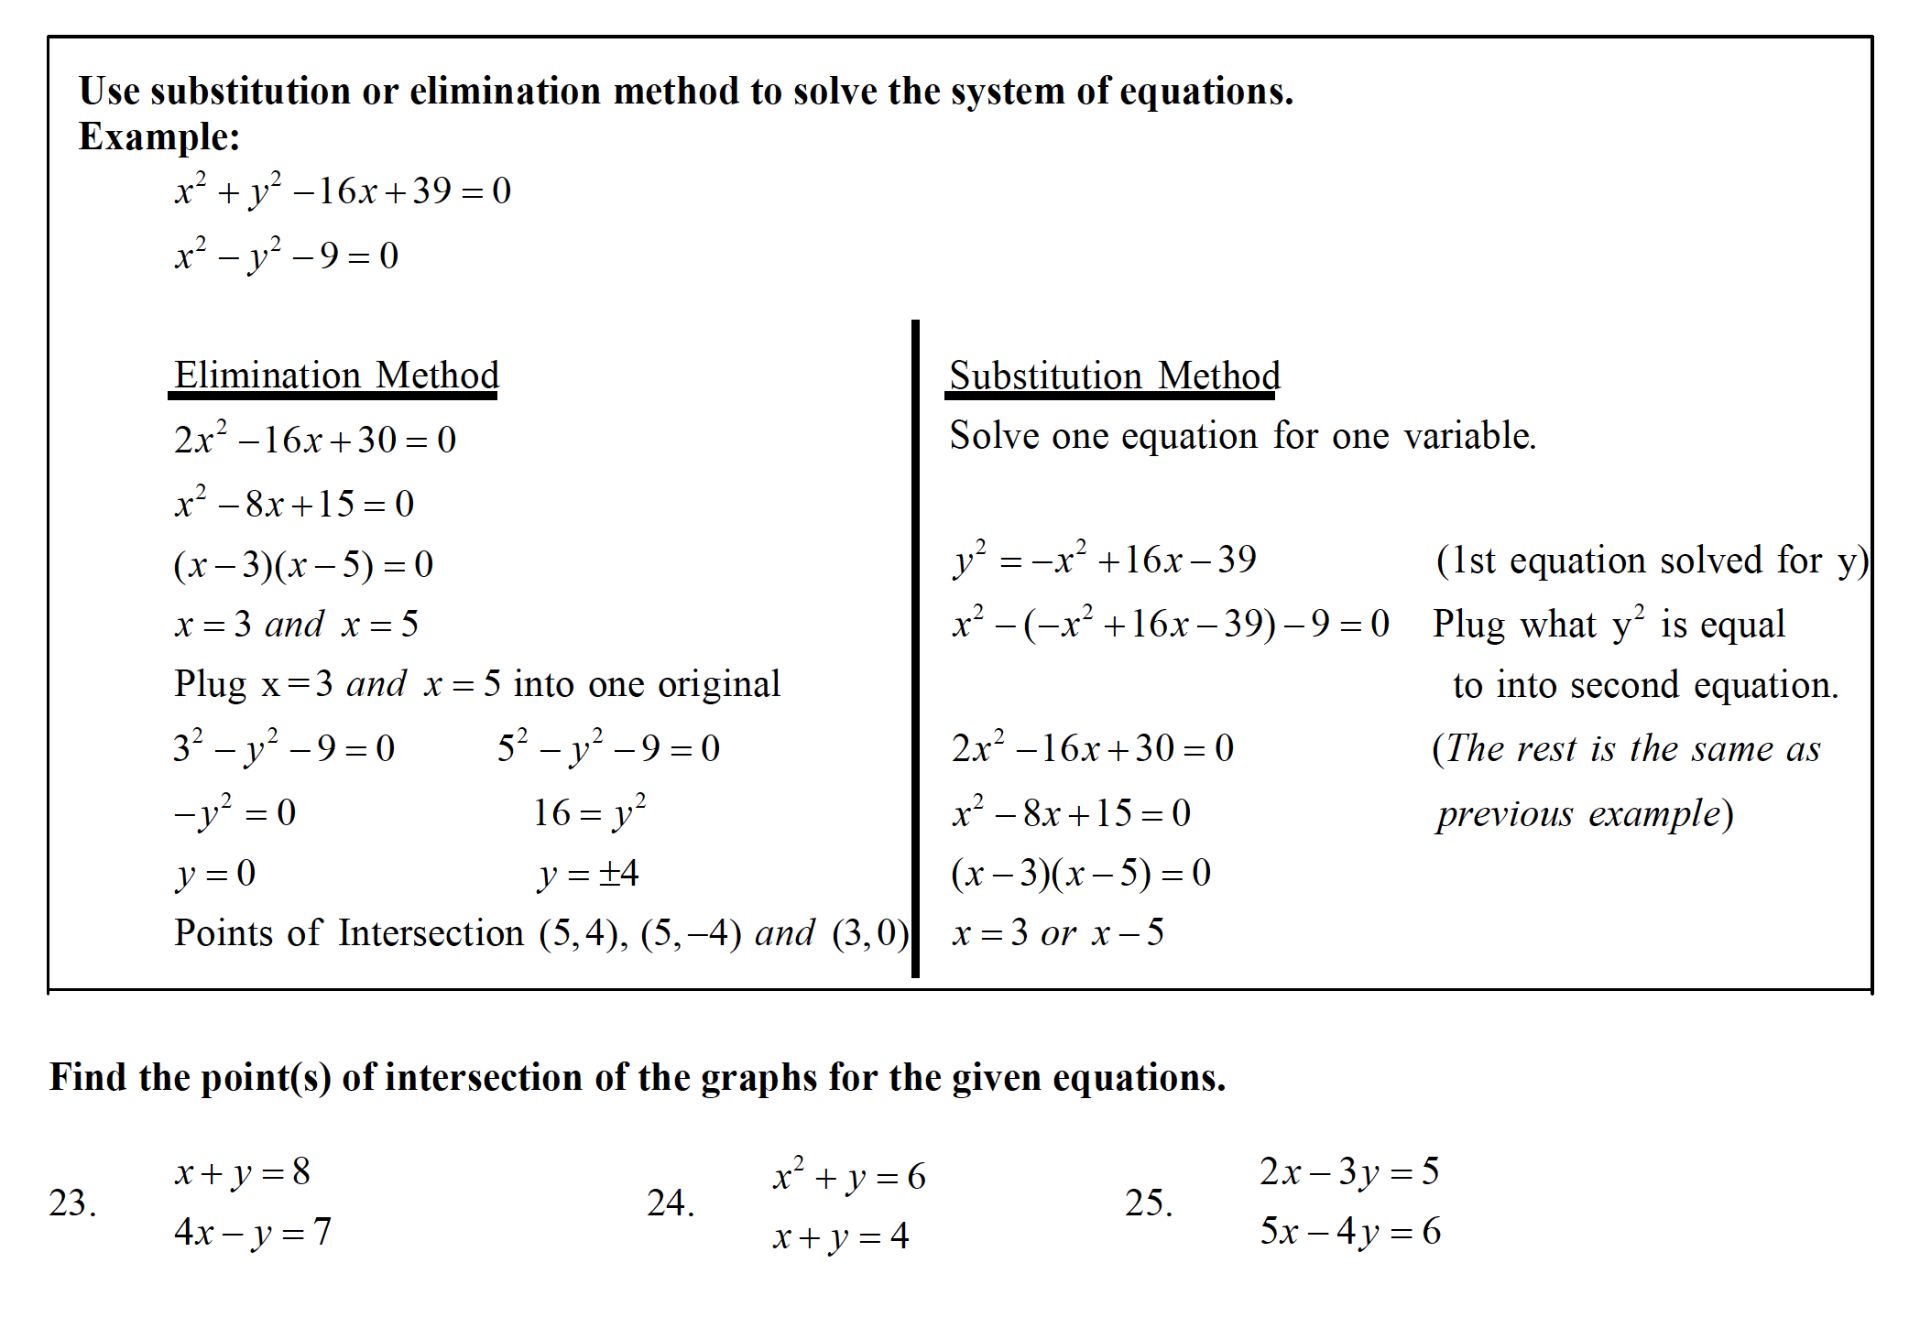
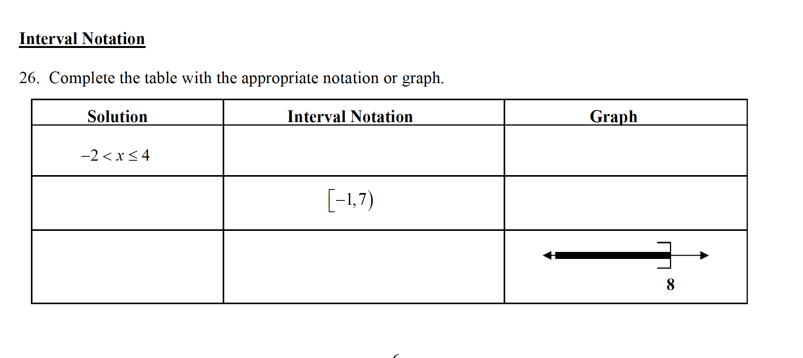
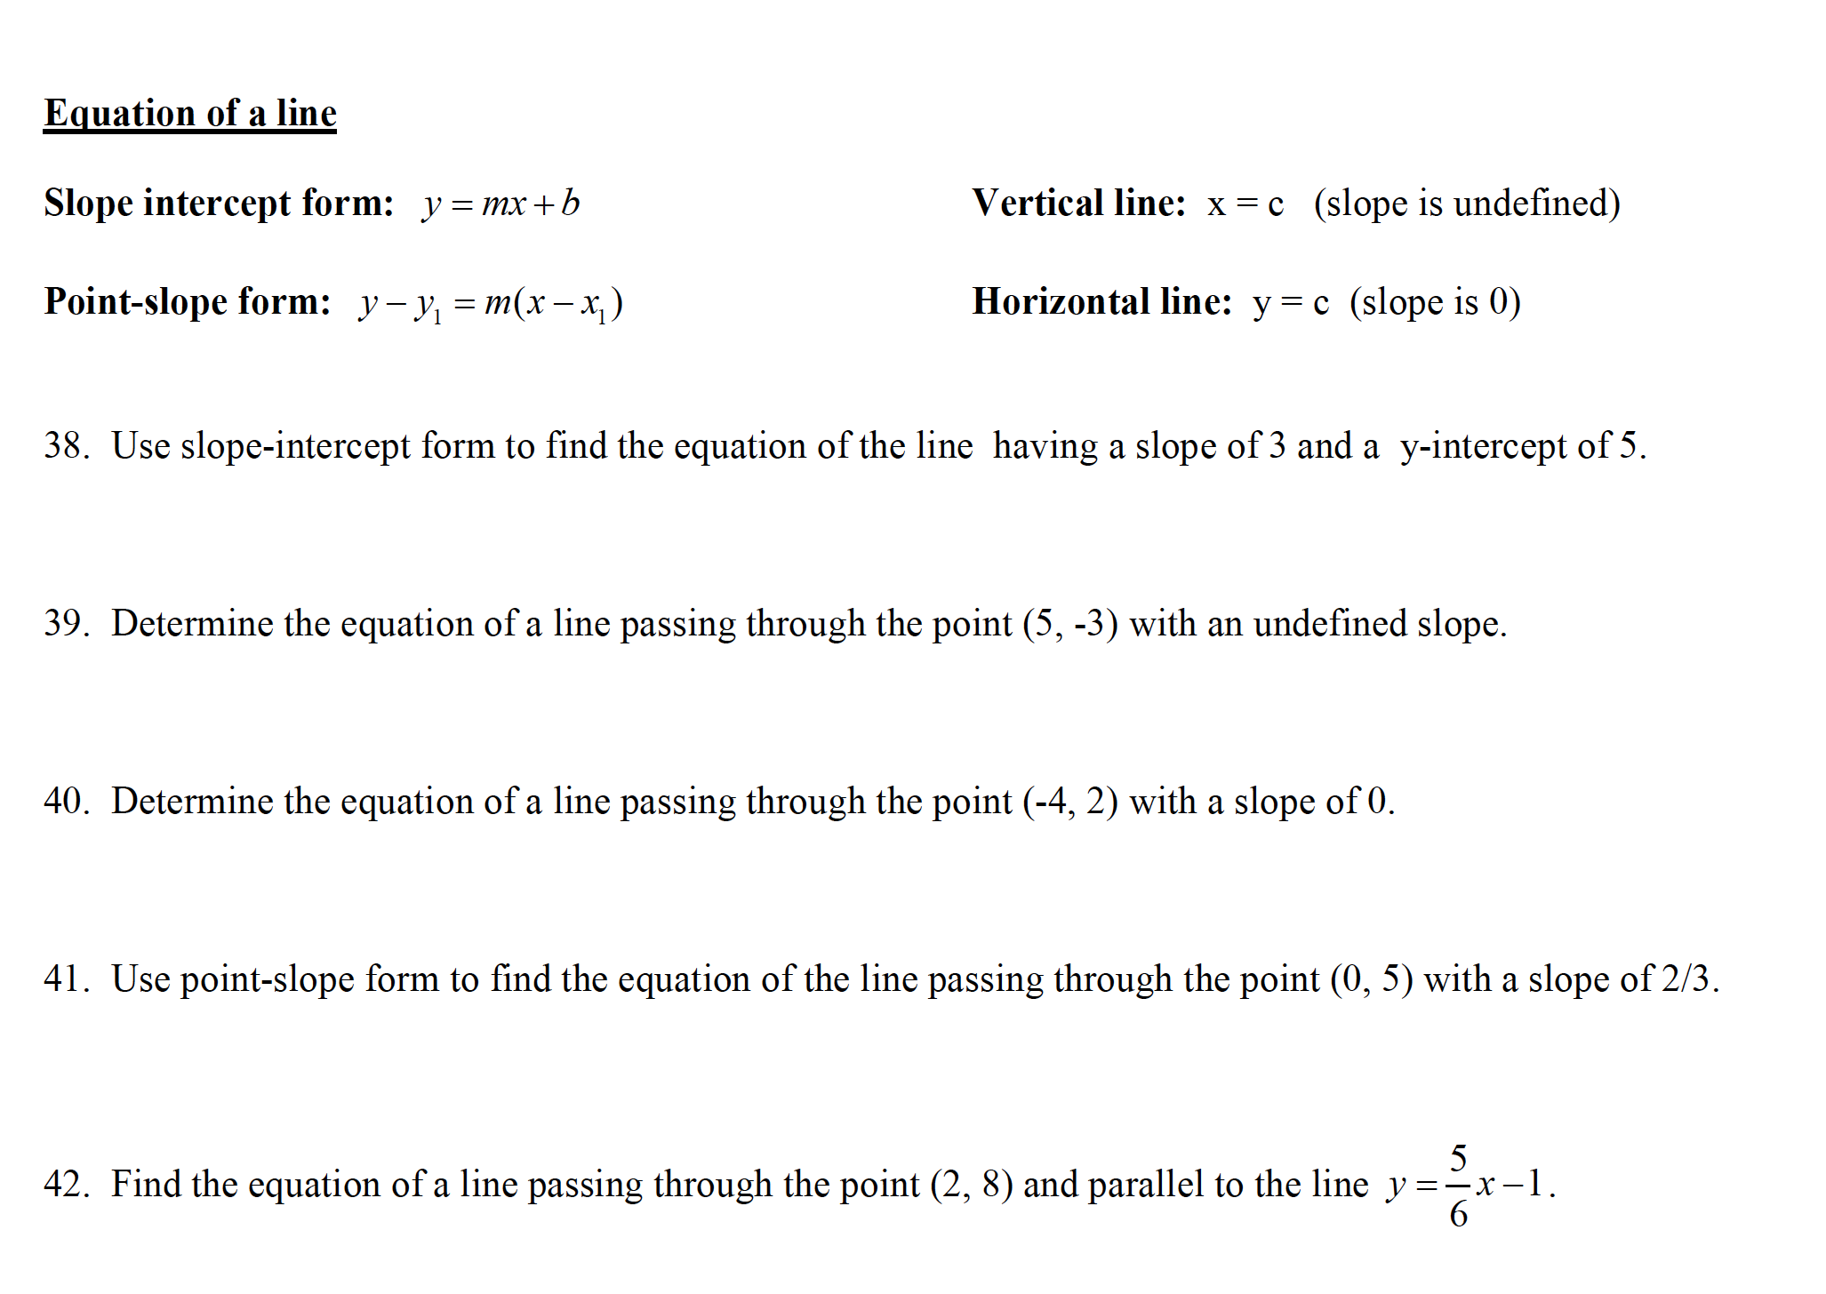
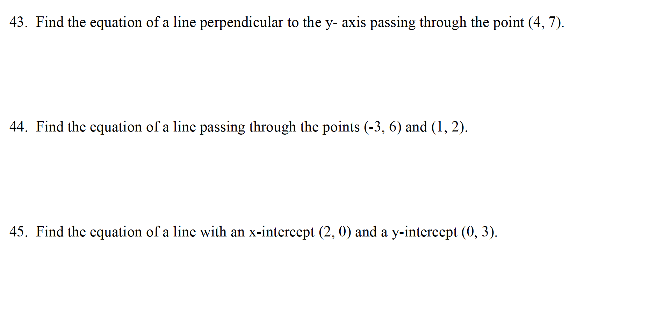

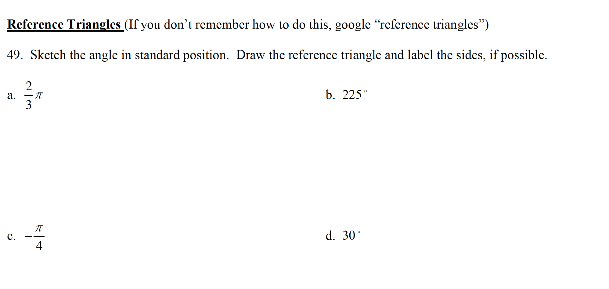
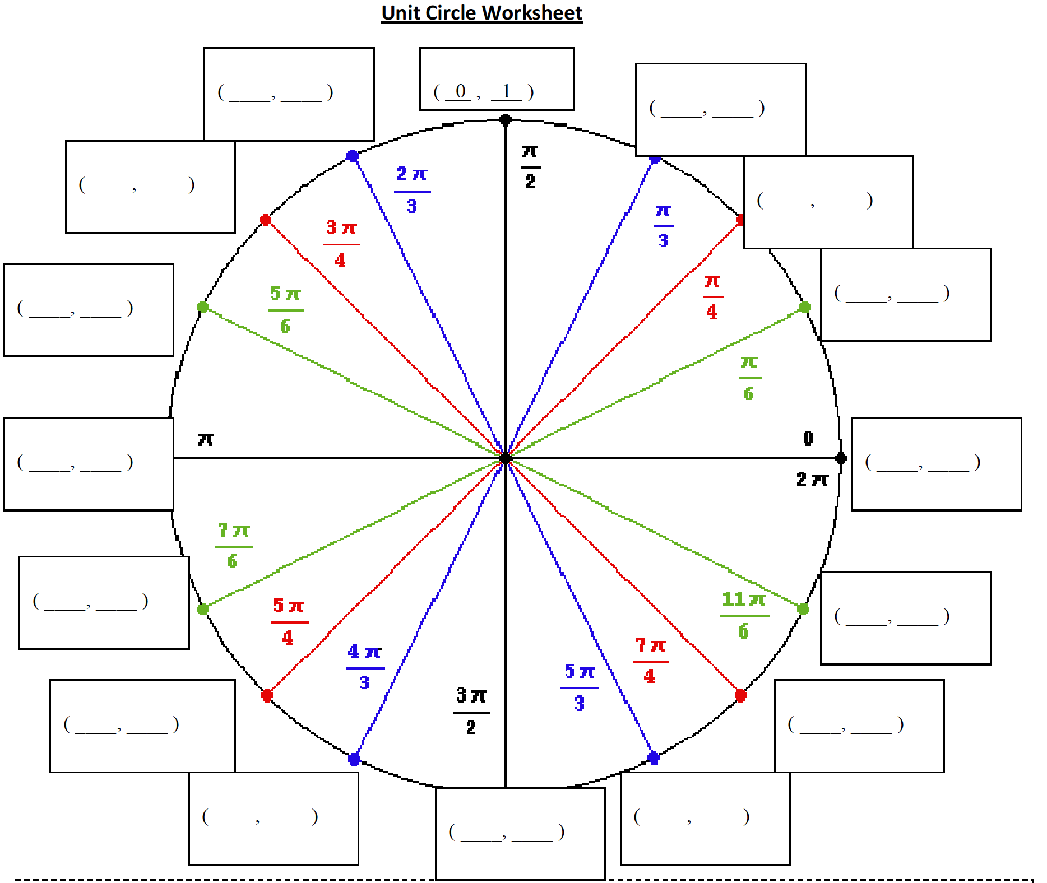

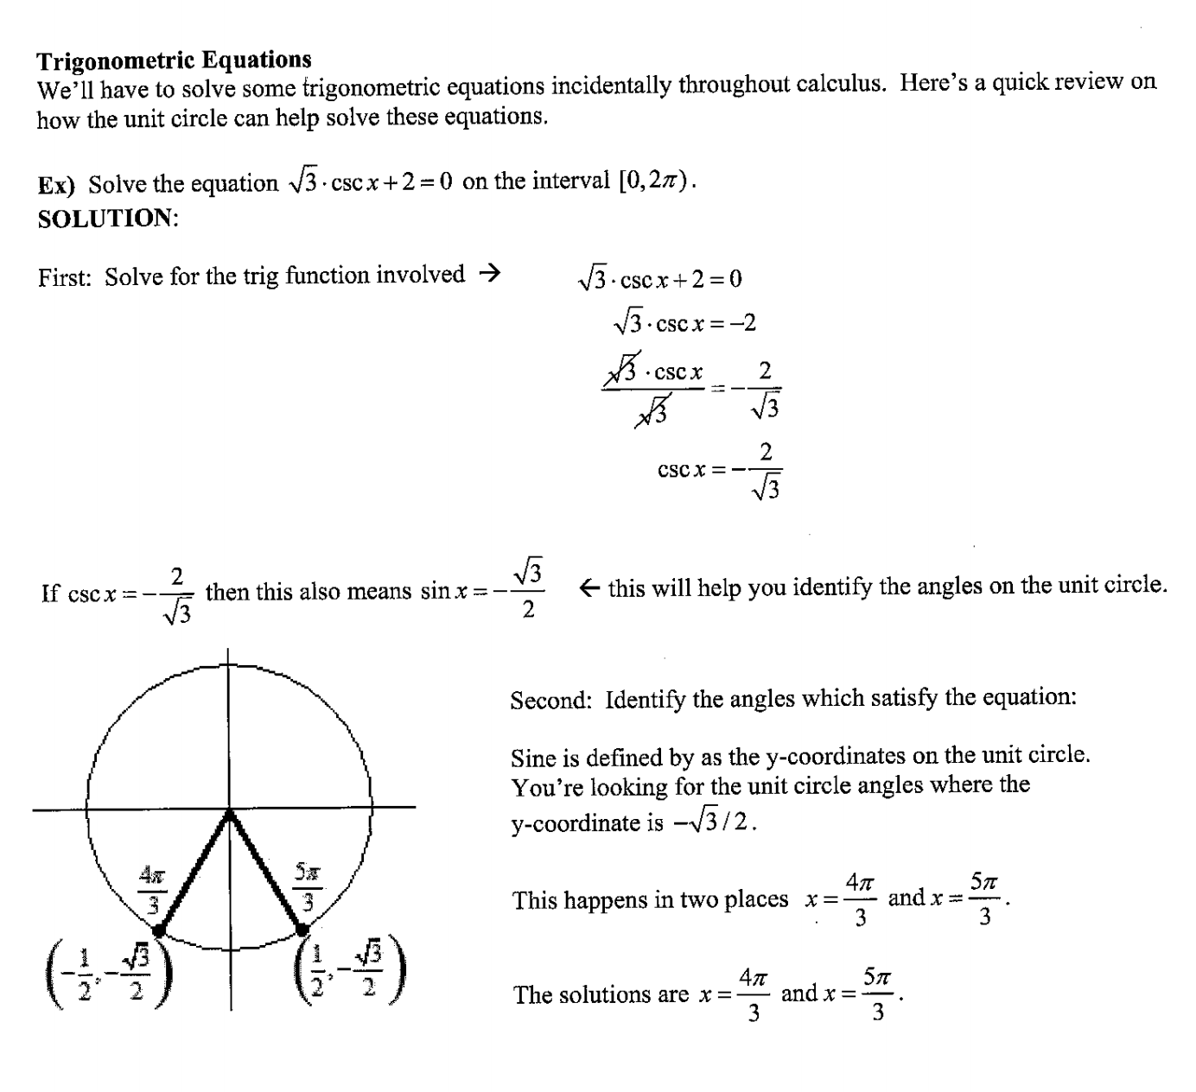

50. 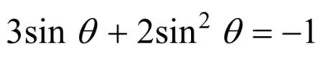 51. 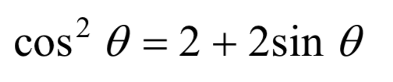

52.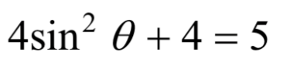 53.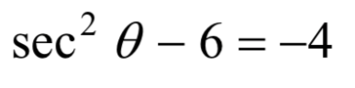

Know these…
