Welcome to Anatomy and Physiology!!!

In this packet you will find assignments to complete over the summer break. These assignments will be due when school starts back in August/September. The main topics included in this assignment are cell structure and function (for review), basic chemistry (for review), and macromolecules/organic compounds. You will need to find the information using a variety of web resources. The reason you will need to use the web is we are in the process of getting new textbooks for next year and the e-text is not available this summer.

The assignment is as follows:
- Complete the questions/topics on the chemical level of organization.
- Complete the questions/topics Cellular Level of Organization.
- All answers should be typed and in complete sentences when appropriate.

If you have any questions or issues please email me at kradomsky@bwschools.net.

Have a great summer and I will see you in August.
Anatomy and Physiology Summer Assignment
1. Define/explain anatomy.
2. Define/explain physiology.

Please research and answer the following questions dealing with the chemical level of organization:
1. Describe an atom (structure, components, etc…) and how atomic structure affects interactions between atoms.
2. Compare ways in which atoms combine to form molecules and compounds (explain the different types of bonds).
3. Distinguish between the major types of chemical reactions that are important to studying physiology.
4. Describe the crucial role of enzymes in metabolism.
a. What are enzymes?
b. How do they work/function?
c. Describe substrate and active site.

5. Distinguish between organic and inorganic compounds.
6. Explain how the chemical properties of water make life possible (explain in detail the various properties of water).
7. Discuss the importance of pH and the role of buffers in the body fluids.
a. Describe the ph scale.
b. Why is it important for our body to maintain a certain ph and what is that ph.

8. Describe the physiological roles of inorganic compounds.
9. Describe the structure, functions, and types (with examples) of the following major organic compounds:
a. carbohydrates
b. lipids
c. proteins
d. nucleic acids

10. Discuss the structures and functions of high-energy compounds.
a. ATP and ADP
b. How are the produced?
c. Why are they important to the function of the body?

Please research and answer the following questions on the cellular level of organization:

1. List the functions of the plasma (cell) membrane and the structural features that enable it to perform those functions.

2. What is the function of the following organelles?
a. smooth endoplasmic reticulum
b. rough endoplasmic reticulum
c. mitochondria
d. ribosomes
e. nucleolus
f. microfilaments & microtubules
g. lysosomes
h. golgi apparatus
i. centrioles

3. Identify the labeled organelles/structures of the cell from the drawing below.
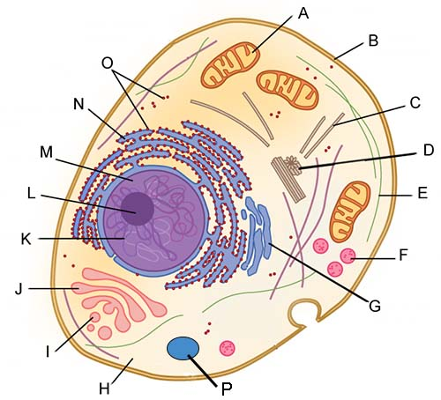

3. Explain the functions of the cell nucleus and discuss the nature and importance of the genetic code.

4. Describe each of these processes: phagocytosis, pinocytosis, and exocytosis

5. What is the difference between active transport and passive transport? Give a specific example of each type.

6. Describe the processes of cellular diffusion and osmosis, and explain their role in physiological systems.

7. What is the difference between hypertonic, hypotonic, & isotonic? What will happen to cells placed in each type of solution?

8. Describe the process of making and exporting a protein from a cell.

9. Explain the origin and significance of the transmembrane potential.

10. Describe the stages of the cell life cycle, including mitosis, interphase, and cytokinesis, and explain their significance.

11. Discuss the regulation of the cell life cycle and the relationship between cell division and cancer.

12. Explain the process of cellular respiration and why it is important for the cell.

